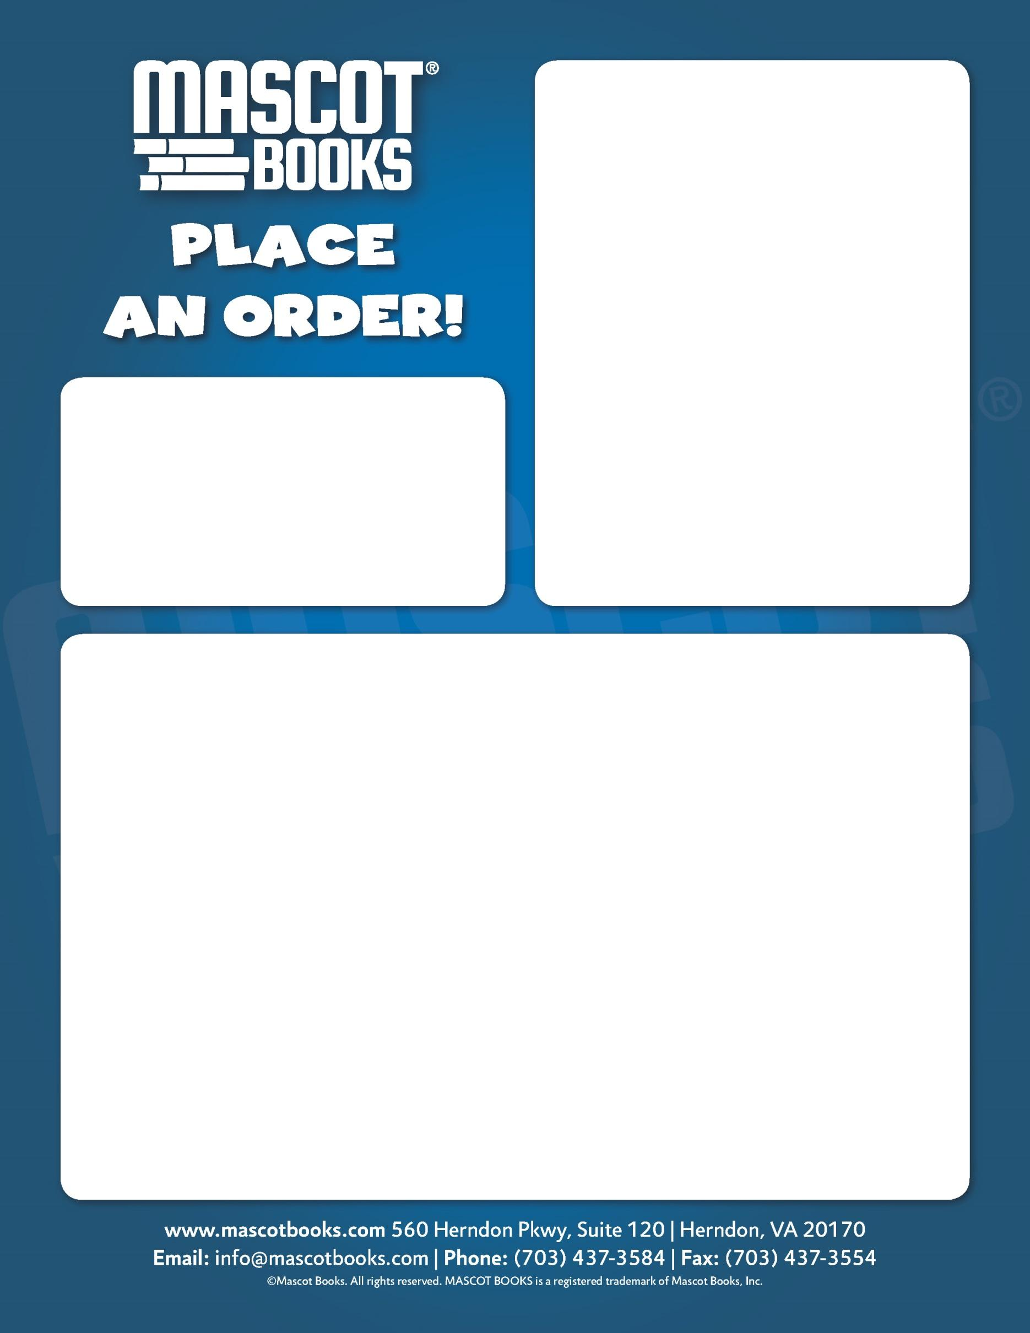

Place an Order Today!

Return this Order Form to your child’s teacher along with cash or check made out to the Haycock PTA. We’ll send your copy home with your child in a sealed envelope. **THIS IS YOUR LAST CHANCE TO BUY THIS UNIQUE LIMITED EDITION BOOK AT COST! They will NOT be sold again!**

**Quantity: ______________ x $7.50 each = _____________ Total**

**Student’s Name: ________________________________**

**Teacher: ______________________________**

**Please contact Karen Leiser at** [**kaleiser@leiserlaw.com**](mailto:kaleiser@leiserlaw.com) **with any questions.**

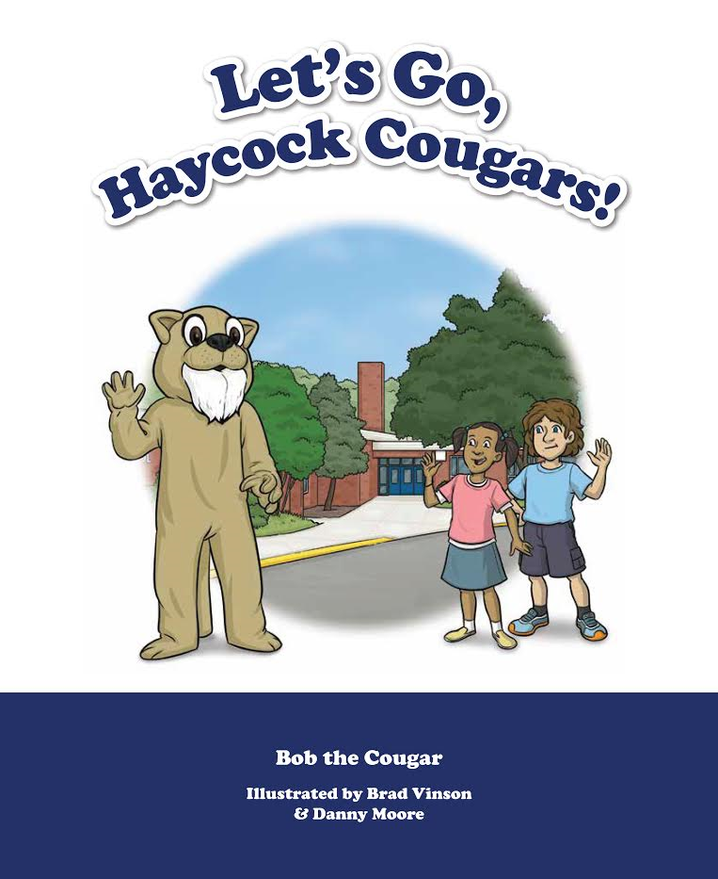

**CLEARANCE SALE!!**

**Now just $7.50!!**

**Order your keepsake copy of**

**Let’s Go, Haycock Cougars**

**featuring our school mascot,**

**Bob the Cougar!**